Introduction to Cisco ASA 5505 Firewall

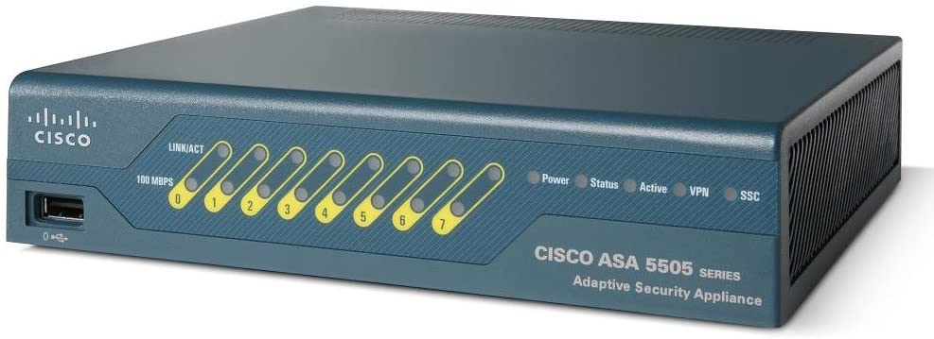

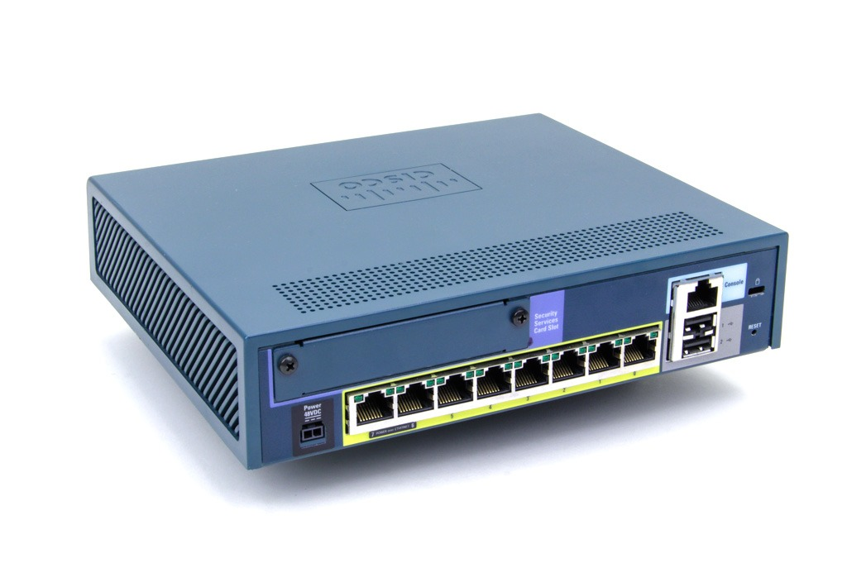

**Purpose;** For thislesson we began to familiarize ourselves with Cisco firewalls and the ASA 5505 Cisco Firewall in particular. This is the beginning of a long journey with Cisco firewalls that will teach us how to configure, enable and utilize to its fullest ability.

**Background information on lab;** The Cisco ASA 5505 is a full-featured firewall for small business, branch, and enterprise environments. It delivers high-performance firewall, SSL and IPsec VPN, and rich networking services in a modular, immediately operational appliance. Using the integrated graphical Cisco Adaptive Security Device Manager (ASDM), the Cisco ASA 5505 can be rapidly deployed and easily managed.  For this lab we used Cisco`s adaptive security device manager, a useful GUI that allowed us to manage the firewall appliance.

**Lab Summary;** Throughout this lab we figured out how-to plug-in turn on and get the Cisco ASA 5505 firewall functioning. To do this we used our serial to usb cable to the console port and connected our ethernet cable from our laptop to the firewall. Following this we downloaded putty an open source terminal emulator, which is how we will be changing the default configurations of the Cisco ASA 5505 firewall. After downloading putty, we launched the application selected our serial connection and opened the terminal under COM3. After launching the terminal emulator, we were able to see the firewall booting for the first time, a truly momentous occasion. When our router boots we will need to reset it to the factory defaults so after entering configuration terminal we enter

Config factory-default

Then confirm and wait for the firewall to be reset.

To enter recovery mode for a password we first power off the asa, and then power on. After startup, press the escape key when you are prompted to enter rommon mode. Enter the following command

rommon #1> confreg 0x41

Followed by the command

Rommon #1> confreg

Then you wish to change the configuration

*Current Configuration Register: 0x00000041*

*Configuration Summary:*

*boot default image from Flash*

*ignore system configuration*

*Do you wish to change this configuration? y/n [n]:* ***y***

Reload the ASA

rommon #2> ***boot***

Launching BootLoader...

Boot configuration file contains 1 entry.

Loading disk0:/asa800-226-k8.bin... Booting...Loading...

Acesss privileged mode

hostname> ***enable***

The password is blank so all you need to do is press enter when prompted for the password and then load the running configuration by using the copy startup-config running-config if you have a configuration set or have fun configuring for the first time.

If you would like to disable this command on the ASA enter no service password-recovery to avoid the user from entering ROMMON mode.

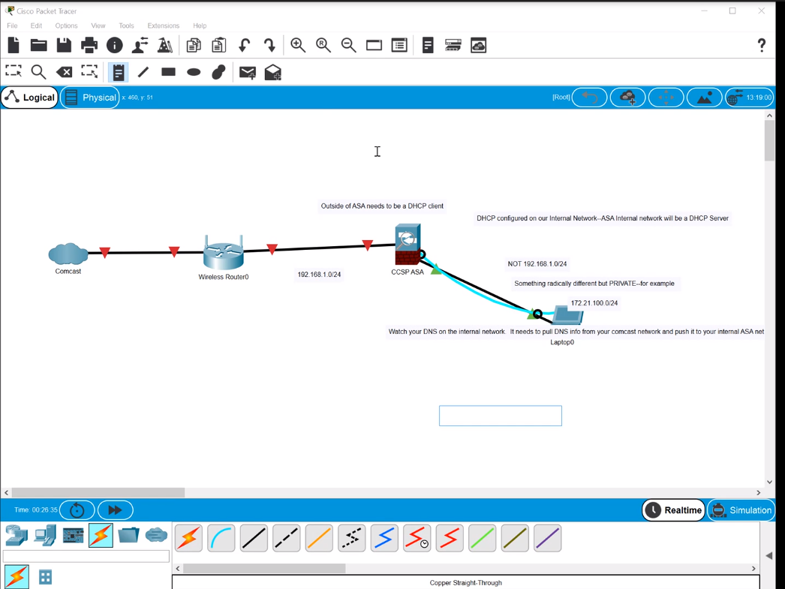

**Problems;** The beginning of this lab was quite simple, and I had no problems other than familiarizing myself with the differences between routers and switches which I am used to and the physical layout of the Cisco ASA Firewall. But configuring the rest of the firewall with ASDM will prove to be a challenge.

**Conclusion;** In this lab we were able to recover a password through disaster recovery mode and reset a Cisco ASA 5505 firewall to its factory defaults. This lab was incredibly helpful in that I learned the general layout of the firewall alongside learning how they work within the network.